Proof of Concept – Digital Banking – Secure Handling of Credentials
<no ref.>
Secure Handling of Credentials

Version No. | Description | Updated By | Date
0.1 | Initial Document Creation | Brian Coghlan | March 30, 2020
0.2 | Reviewed and Provided Feedback | Reinhardt Tonn | March 31, 2020
0.3 | Feedback incorporated | Brian Coghlan | March 31, 2020

Contents
TOPIC 3
BACKGROUND 3
APPROACH 4
Stage 1: Java Server-side Encryption/Decryption 5
Stage 2: HTML Test Page in Chrome browser using WebCrypto 7
Stage 3: Rolling Keys and Tokenization of Encrypted Data 11
Stage 4: Cross-browser compatibility 15
Final Specifications 19
ATTACHMENTS 19
DECISION 20
PREPARED BY: 20
REVIEWED BY: 20
APPROVED BY: 20

TOPIC
This document provides details surrounding a proof of concept done to encypting sensitive data in the browser (Avoka) for transmission to the T24 backend for decryption. This includes one possible solution and working set of specifications for encryption in Javascrypt using the WebCrypto libraries as well as those for Java decryption. Various capabilities and constraints of browser and Java support will be discussed.

BACKGROUND
From the Architecture Request for Decision:
The Digital Onboarding journey flow requests the prospective customer to supply credentials that will be used for online banking or authentication with the help desk. The credentials are entered by the customer into the Avoka application and traverses through AWS infrastructure, CWB infrastructure, the API Gateway (Mule) and are finally encrypted and stored in the T24 core banking system.
Although the transport protocols from browser to server and on to CWB systems is based on TLS 1.2, there is the real possibility that the credentials could be captured by intermediate components (network routers, firewalls, load balancers, application logs) and stored in clear text and presented to human actors. To avoid this potential compromise, this AD identifies options that will significantly reduce this risk.
In the relatively near future (e.g. 12-18 months), customer credentials will be migrated from T24 to Okta. It is assumed this solution will need to be revisited to take advantage of the native capabilities of Okta. This will impact how the credentials are captured and distributed to the customer and will likely reduce the involvement of the components required in CWB’s current state architecture.
Any solution identified here should be considered short term (12 – 18) months. Subsequent decisions regarding the secure handling of credentials with Okta will supersede this decision.

APPROACH
The proof of concept was executed in 4 stages:
- Server side Java programs to demonstrate public/private key encryption/decryption
- HTML Test Page in Chrome browser using WebCrypto
- Rolling public keys and tokenization of encrypted data
- Cross-browser compatibility

Stage 1: Java Server-side Encryption/Decryption
Objective(s):
- Demonstrate encryption/decryption using RSA-OAEP algorithm/padding using public/private keys
- Separate keystores used by ‘client’ and ‘server’ executables, ensuring no shared resources

Steps:
- Create ‘server’ keystore – This represents the T24 keystore where the keypairs are generated and public keys exported to Avoka.

Keystore Name: | skeystore.jks
Store Type: | PKCS12
Key Size: | 2048
Key Alias: | poctestkey
Command: | keytool -genkeypair -alias poctestkey -keyalg RSA -keysize 2048 -dname "CN=Brian Coghlan,OU=Users,OU=CWB,DC=cwb,DC=local" -storetype PKCS12 -keystore temenos_journey_server.jks -storepass abcdef

- Export public key certificates – Creates the public key certificates for importing into the Avoka (client) keystore

Keystore Name: | skeystore.jks
Key Alias: | poctestkey
Certificate Name: | pubcert.cert
Command: | keytool -exportcert -alias poctestkey -storetype PKCS12 -keystore skeystore.jks -file pubcert.cert -rfc -storepass abcdef

- Create ‘Avoka/client’ keystore and import public key certificate

Keystore Name: | ckeystore.jks
Store Type: | PKCS12
Alias: | poctestkey
Certificate Name: | pubcert.cert
Command: | keytool -importcert -alias poctestkey -storetype PKCS12 -keystore ckeystore.jks -file pubcert.cert -rfc -storepass abcdef

- Java encryption executable

- Load ‘client’ keystore
- Retrieve the certificate by alias
- Get the public key from the certificate
- Get an instance of a Cipher using the RSA algorithm
- Encrypt the data
- Output the encrypted data using base64 encoding

- Java decryption executable

- Load ‘server’ keystore
- Get an instance of a Cipher using the RSA algorithm (“Cipher SPI”)
- Get the private key by alias
- Decrypt the data

Outcome(s):
- The server and client executables were able to encrypt and decrypt consistently using just the RSA algorithm as the cipher service provider interface

NOTE: In the next stage of the POC, some of the defaults used by the Javascript WebCrypto libraries are different than the basic Java RSA settings. Additional parameters were later added to the Java code to support OAEP padding. Java RSA uses SHA-1 hashing while WebCrypto SHA-256

Stage 2: HTML Test Page in Chrome browser using WebCrypto
Objective(s):
- Introduce Javascript encryption in simple web page using WebCrypto (subtlecrypto)
- Limited to Chrome browser which has broad support for WebCrypto
- Decrypt output of Javascript using server-side programs from Stage 1

Steps:
- Implement local HTML test page with Javacript calls to WebCrypto functions
  - Inputs:
    - private key
    - public key
    - data to enrypt
    - button to encrypt data
    - encrypted data
- Private and public keys statically defined (but can be overridden) after being written to file by the Java executables created in Stage 1
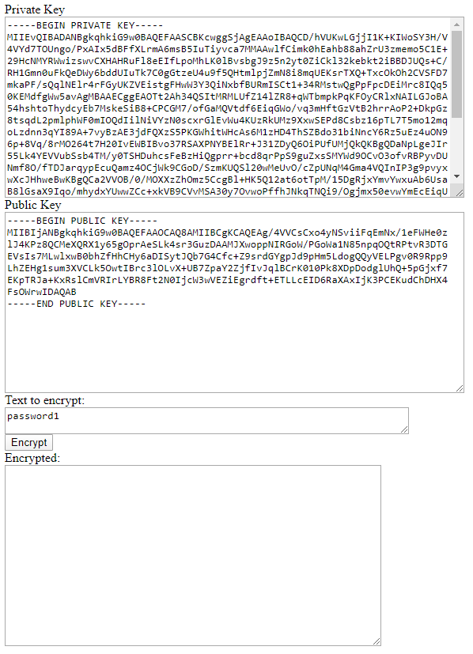
- On button click, Javascript makes calls to importKey (based on public key input) and subsequently encrypt
  - importKey parameters:
Format: | spki
Key Data: | public key converted to array buffer
Algorithm: | RSA-OAEP with SHA-256 hash
Extractable: | true
Usages: | encrypt

  - encrypt parameters:
Algorithm: | RSA-OAEP
Key: | <output from importKey>
Data: | Array buffer of data to encrypt

- Copy output of page to ‘encrypted_data.txt’ file and execute Java decrypt program

NOTE: Due to inconsistencies between the Javascript WebCrypto and Java library hash defaults, modifications were made to the Java parameters to align the two libraries

Outcome(s):
- Changes made to Java Cipher initialization to specify alternate OAEP padding

Language | Hash Default
Javascript | SHA-256
Java | SHA-1

Changes required to Java Cipher initialization:

Old:
cipher = Cipher.getInstance("RSA");

Key key = this.decryptkeystore.getKey(keyAlias, "password").toCharArray());

cipher.init(Cipher.DECRYPT_MODE, key);

New:
cipher = Cipher.getInstance("RSA/ECB/OAEPWITHSHA-256ANDMGF1PADDING");

oaepParameterSpec = new OAEPParameterSpec("SHA-256", "MGF1",
MGF1ParameterSpec.SHA256,
PSource.PSpecified.DEFAULT);

Key key = this.decryptkeystore.getKey(keyAlias, "password").toCharArray());

cipher.init(Cipher.DECRYPT_MODE, <key>, oaepParameterSpec);

NOTE: In the above code where “RSA/ECB/…” is used, it might be possible to use “RSA/NONE/…”. Further testing is required.

- Successful encryption in Javascript layer with subsequent Java decryption

Stage 3: Rolling Keys and Tokenization of Encrypted Data
Objective(s):
- Allow for multiple keypairs to be generated and public keys distributed
- Browser encrypts data using any of the public keys provided
- Browser base64 encodes the encrypted data and includes public key identifier
- Server side library is able to decode and decrypt data

Steps:
- Generate 2 keypairs in the server side keystore
NOTE(S):
  - Keystore now rename to ‘temenos_journey_server.jks’
  - Key aliases are now ‘dcokey0’ and ‘dcokey1’
- Public keys are exported from the keystore and written to file
- Inputs created in the HTML page and both public keys pre-populated
- Additional dropdown added to identify either key 0 or 1 as the key to use
- Inputs added to display the new JSON encoded object showing the key identier (kid) and encrypted data as well as the Base64-encoded final output of the page:
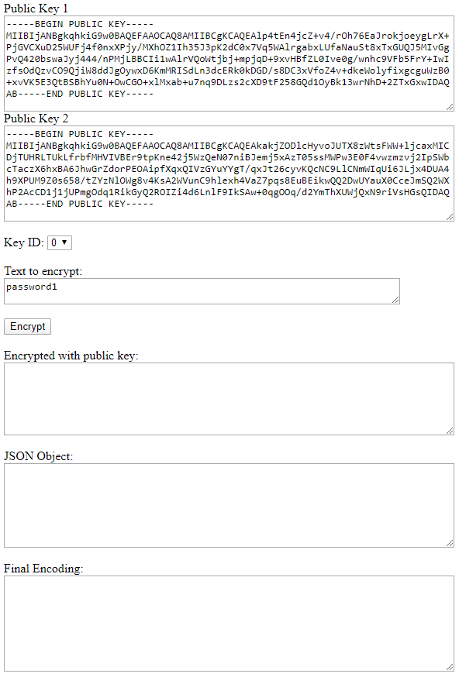

- The page will create a new JSON object with the following format:
{ "kid": "0", "value": "<encrypted data>" }

- The string representation of the JSON object is base64 encoded as seen in the ‘Final Encoding’
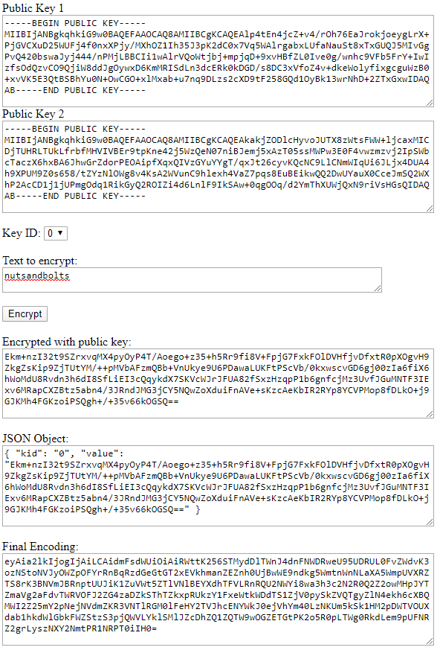

- Java modifications include:
  - Decode the base64 output
  - Retrieve the key identifier
  - Decrypt the value based on the private key alias

Outcome(s):
- Base64 encoding introduced
- Base64 encoding of JSON string allows for additional information to be passed in a single value without changing the definition of the payload and the data itself remains obfuscated
- Algorithm about which public key to use when encrypting needs to be identified and implemented by Avoka
- Method used to house the public keys in Avoka and the deployment/versioning of them needs developed

Stage 4: Cross-browser compatibility
Objective(s):
- Test WebCrypto development across browsers
- Identify issues and develop workarounds
NOTE: The following tests and modifications were performed on code fully functional on the Chrome browser
Steps:
MS Edge – TextEncoder not support in all versions of Edge
- A polyfill is added to support the TextEncoder function call.

<script src="https://dl.dropboxusercontent.com/s/47481btie8pb95h/FastestTextEncoderPolyfill.min.js?dl=0"></script>

If Avoka does not have an equivalent library in-house, recommend rebundling this one into a new library with credits to the original author.
MS Edge – Encrypt Hash
- Call to subtlecrypto encrypt function fails. Investigation reveals the hash function must be explicitly provided

Old:
window.crypto.subtle.importKey(
"spki",
pemToArrayBuffer($('#pubkey').val()),
{
name: "RSA-OAEP",
hash: {name: "SHA-256"} // or SHA-512
},
true,
["encrypt"]
).then(function(key) {
window.crypto.subtle.encrypt(
{
name: "RSA-OAEP",
},
key, //from generateKey or importKey above
enc.encode($('#pwdinput').val()) //ArrayBuffer of data you want to encrypt
).then(function(encrypted){
…
});

New:

window.crypto.subtle.importKey(
"spki",
pemToArrayBuffer($('#pubkey').val()),
{
name: "RSA-OAEP",
hash: {name: "SHA-256"} // or SHA-512
},
true,
["encrypt"]
).then(function(key) {
window.crypto.subtle.encrypt(
{
name: "RSA-OAEP",
hash: { name: "SHA-256" }
},
key, //from generateKey or importKey above
enc.encode($('#pwdinput').val()) //ArrayBuffer of data you want to encrypt
).then(function(encrypted){
…
});

- The final code standardized on the following specification across all calls:
<script>
// Reference:
// https://github.com/diafygi/webcrypto-examples/
//
// Base algorithm:
//
window.RSAOAEP = {
name: "RSA-OAEP",
modulusLength: 2048,
publicExponent: new Uint8Array([0x01, 0x00, 0x01]),
hash: {name: "SHA-256"},
}
</script>

<script>
…
window.crypto.subtle.importKey(
"spki",
pemToArrayBuffer($('#pubkey').val()),
RSAOAEP,
true,
["encrypt"]
).then(function(key) {
window.crypto.subtle.encrypt(
RSAOAEP,
key, //from generateKey or importKey above
enc.encode($('#pwdinput').val())
).then(function(encrypted){
…
});
</script>

MS Internet Explorer – calls to subtlecrypto return events and not Promises
- All other browsers return promises from their calls to importKey and encrypt. IE returns events requiring code to identify which browser is being used
var isIE = /*@cc_on!@*/false || !!document.documentMode;

- Call event based version of the crypto functions:
if (isIE == true) {
// Call msCrypto functions using event model, not Promises
//
window.msCrypto.subtle.importKey(
"spki",
pemToArrayBuffer(keys[document.getElementById("keyid").value]),
RSAOAEP,
true,
["encrypt"]
)
.oncomplete = function (e){
var key = e.target.result;

try {
window.msCrypto.subtle.encrypt(
RSAOAEP,
key,
enc.encode($('#pwdinput').val())
).oncomplete = function(e) {
var encrypted = e.target.result;

//returns an ArrayBuffer containing the encrypted data

…
};
…
}

Outcome(s):
- Browser compatibility issues:

Browser | Status/Issues
Chrome | None
Mozilla Firefox | None
MS Edge | - TextEncoder  - subtlecrypto.encrypt hash key
MS Internet Explorer | - Array buffer to base64 encoding  - Subtlecrypto returns events and not promises, as does every other browser
Samsung browser | None

Final Specifications
Javascript:

Encryption Algorithm: | RSA
Padding: | Optimal Asymmetric Encryption Padding (OAEP)
Modulus Length: | 2048
Public Exponent: | 65537
Hash function: | SHA-256

Java:

Cipher: | RSA/ECB/OAEPWITHSHA-256ANDMGF1PADDING
OAEP Message Digest Algorithm: | SHA-256
OAEP Mask Generation Function: | MGF1
OAEP Parameter Spec: | SHA-256
OAEP ‘P’ Encoding Value: | Default

ATTACHMENTS
Test HTML page:

Java POC Cryptography Netbeans 8.2 project:

DECISION
n/a

PREPARED BY:
Name: Brian Coghlan

REVIEWED BY:
Name:

APPROVED BY:
The individual or group responsible for the decision are named below. Decisions will be recorded through meeting minute/ emails instead of signatures. Meeting Minutes will be saved with the appropriate RFD in the respective document folder.
Name:

